|  |
| --- |
| pixel ruler activity  Maria Panagopoulou · Ellinogermaniki Agogi, Greece · mariapanago@ea.gr |
| In the following activities you can see how to use a pixel ruler to facilitate your lesson. Through the following examples you will measure the craters on the Moon and the radius of Jupiter moons’ orbit. The second activity is included in the LaSciL demonstrator [Jupiter Moons](https://lascil.eu/index.php/jupiters-moons-2/). |

**

**CRATERS ON THE MOON**

* Find a picture of the Moon. For example you can find some pictures from NASA [here](https://solarsystem.nasa.gov/resources/2460/lunar-near-side/?category=moons_earths-moon).
* Copy the image and after you open the [Online Pixel Ruler](https://www.rapidtables.com/web/tools/pixel-ruler.html) press Ctrl+V.

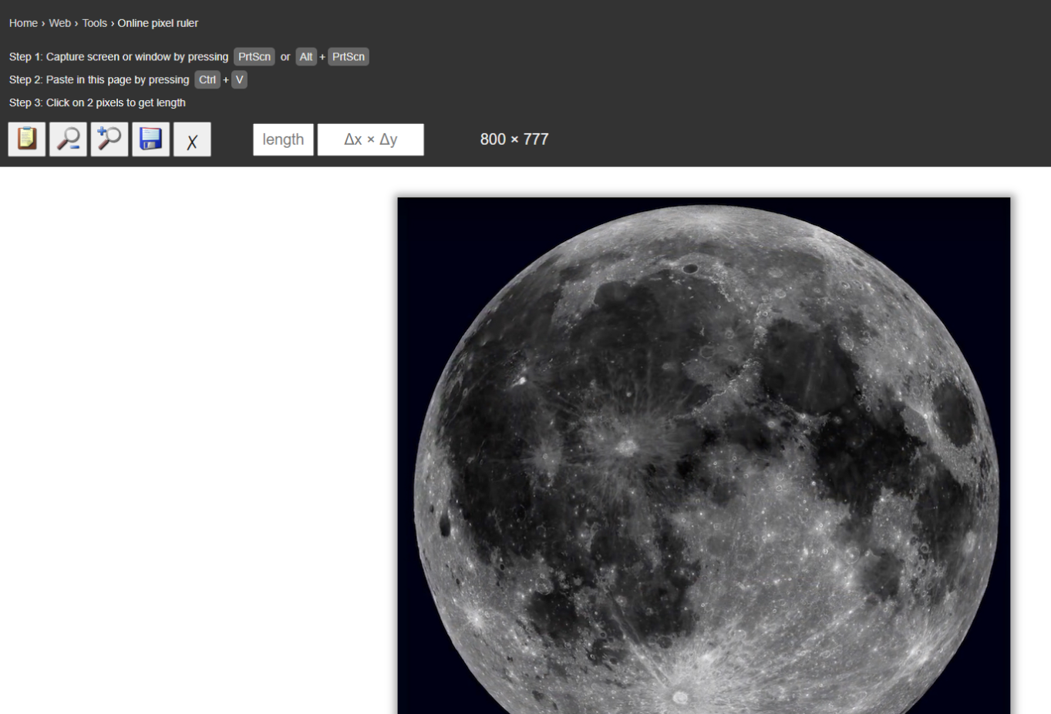

* Zoom in to a crater and measure its diameter. For example you can measure the Tycho crater.

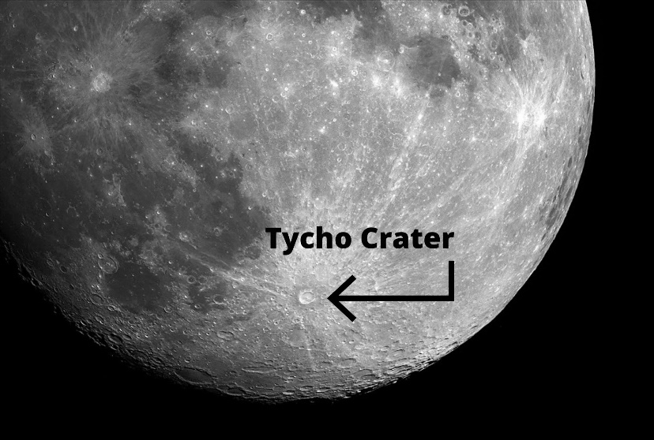

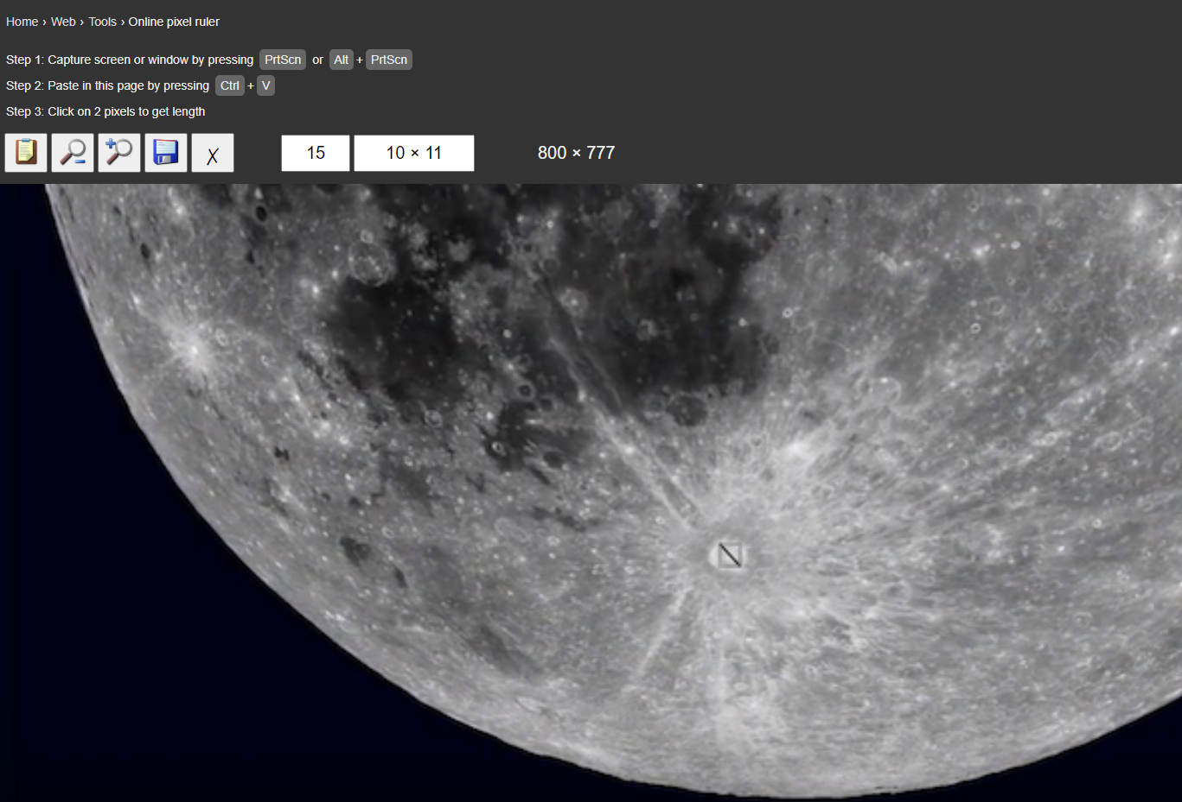

* Convert your measurement to kilometers (Moon’s radius is 3,475 kilometers). To do that you also have to measure the diameter of the Moon with the pixel ruler. For reference the diameter of the Tycho crater is known to be 85 kilometers.
* What do you think you could teach with this activity?

**JUPITER’S MOONS**

* Open the link and familiarize yourself with the Jupiter’s moons simulation. <http://www.skyandtelescope.com/observing/celestial-objects-towatch/jupiters-moons-javascript-utility/#>

Εικόνα που περιέχει κείμενο

Περιγραφή που δημιουργήθηκε αυτόματα

* Download the "Pixel ruler" from the following link <http://www.pixelruler.de/e/download.htm>
* In the simulation keep the Magnitude, Angular Size, Distance and System longitude constant and familiarize yourself with the rest of the options. Try changing the date. You can observe the positions of the satellites concerning Jupiter for various dates and times by changing the time step by step: +/- 10 minutes, +/- 1 hour, +/- 1 day.
* Launch the digital ruler software on your computer.
* Measure the diameter of the planet Jupiter using the digital ruler.
* Study the motion of a satellite. What kind of motion do you observe?
* Experiment with the time options and choose the time step that works for you. By selecting +10min for example you will see the position of the satellites 10 minutes after the start time and investigate whether the movement of your satellite is periodic. If so, measure the period and record it.
* Measure the satellite's maximum distance from Jupiter as a multiple of Jupiter's radius. Galileo did not know in advance the value of Jupiter's radius. However, by expressing the distances of the satellites as multiples of the planet’s radius, he was able to calculate quantitative results for their motion.
* What do you think you could teach with this activity?