

**Light Curve Plotting with AstroImageJ & Excel**

***How to plot light curves using the free image processing software, AstroImageJ***

This worksheet describes how to use your photometry measurements to investigate the changing brightness of your target.

When you have carried out your measurements and obtained your data, you will present your results on graphs to display the **light curves** of the target.

Prior to carrying out this activity, if you have not used the AstroImageJ software previously or carried out photometry, it is recommended that you read through and complete the ‘**Light Curve** **Photometry with AstroImageJ**’ worksheet.

**Presenting your Data**

Step 1: When you have completed the photometric analysis for each of your images in one filter, open your data into an **Excel Spreadsheet**.

Step 2: Choose **Yes** in the error message that appears.

Step 3: If a ‘Test Import Wizard’ box appears, click **Finish**.

Your results should look like those seen in Figure 1. Here the target and comparison stars have been recorded, where the first column represents the number of the frame.

**Figure 1 - Photometry results obtained from AstroImageJ presented in an Excel spreadsheet.**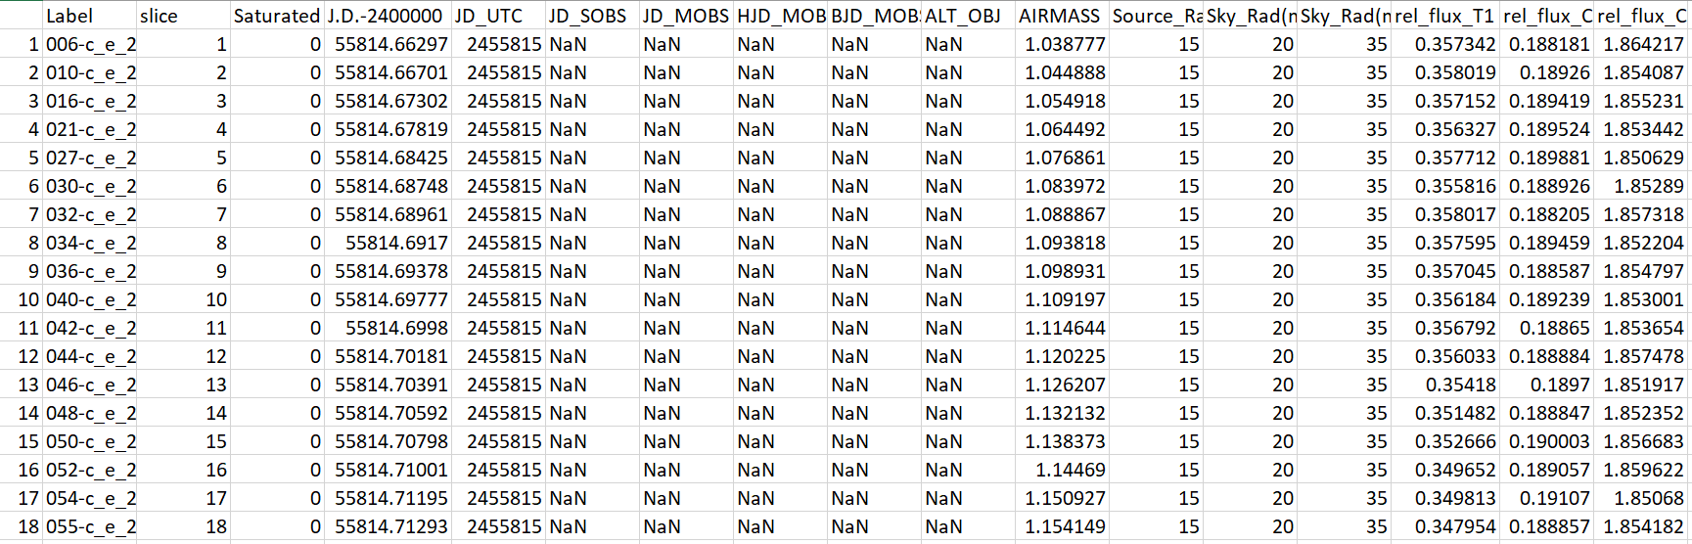

**Julian Date**

The column ‘J.D.-2400000’ is ‘Julian Date minus 2400000’. Julian Date is a system made by astronomers to simplify calculating the difference between two dates. The Julian Date system assigned 1st January 4713BC to be “Day 0”, and we’ve been counting up since then.

Imagine you want to know how many days are between 12th January 2003 and 24th March 2005. In our normal date system you’d have to consider how many days are in each month, as well as leap years. With the Julian Dates, you just have to subtract two numbers.

Since we’re now at such a large number in Julian Days we subtract 2,400,000 from the Julian Date to give a more manageable number. Julian Date minus 2400000 is sometimes called “Modified Julian Date”.

**Calculating Magnitude**

We now need to calculate the **Magnitude**. This is calculated from **rel_flux_T1**.

The **flux** value refers to the number of **photons that fell onto the CCD in a given area** divided by the exposure time, and is a measure of how **bright** the star is. The area for ‘rel_flux_T1’ is the aperture radius that you set.

We convert this value into magnitude (the system astronomers use to describe a star’s brightness) using Equation 1:

**Equation 1 - Calculating magnitude from flux**

*magnitude* = -2.5 x log10*flux*

Step 2: Right click on the column immediately to the right of the ‘rel_flux_T1’ column. Select **Insert**.

Step 3: In the pop up box choose **Entire column**. This should add a new column to the right of ‘rel_flux_T1’ column.

Step 4: Name this column as “mag” (for magnitude).

Step 5: In the first box of this column, type “=-2.5*log10(“, then click on the first box in the ‘rel_flux_T1’ column, followed by typing “(”. After this, press Enter.

Step 6: Drag this box from the little square in the bottom right to the end of the spreadsheet, as 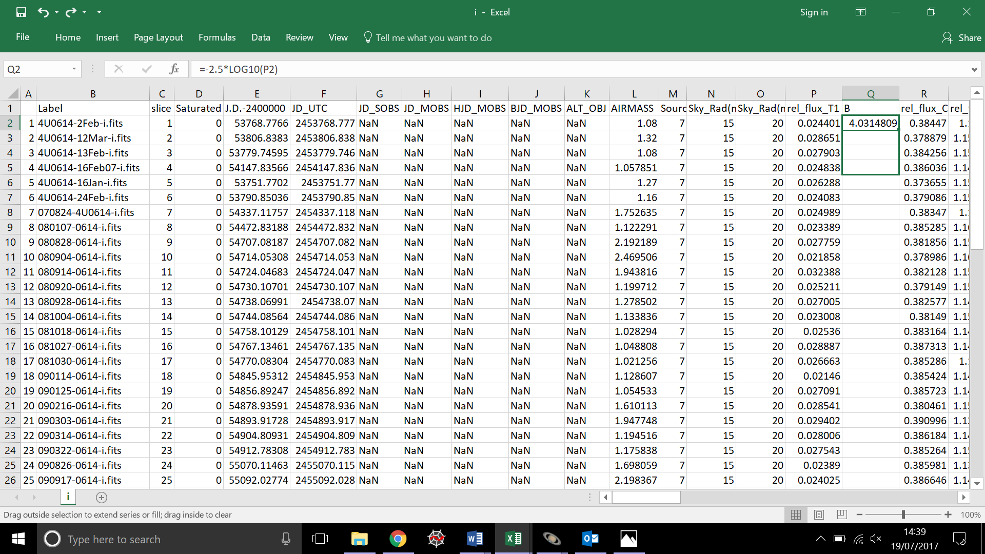shown in Figure 2.

**Figure 2 - Dragging a formula across multiple rows in an Excel spreadsheet.**

**Plotting your Light Curve**

Step 7: To plot your graph, highlight the ‘J.D.-2400000’ column and the new column you’ve created whilst holding ctrl.

Step 8: Go to **Insert -> Scatter Chart** as in Figure 3**.** This should produce a graph displaying magnitude on the y-axis and ‘J.D.-2400000’ on the x-axis.

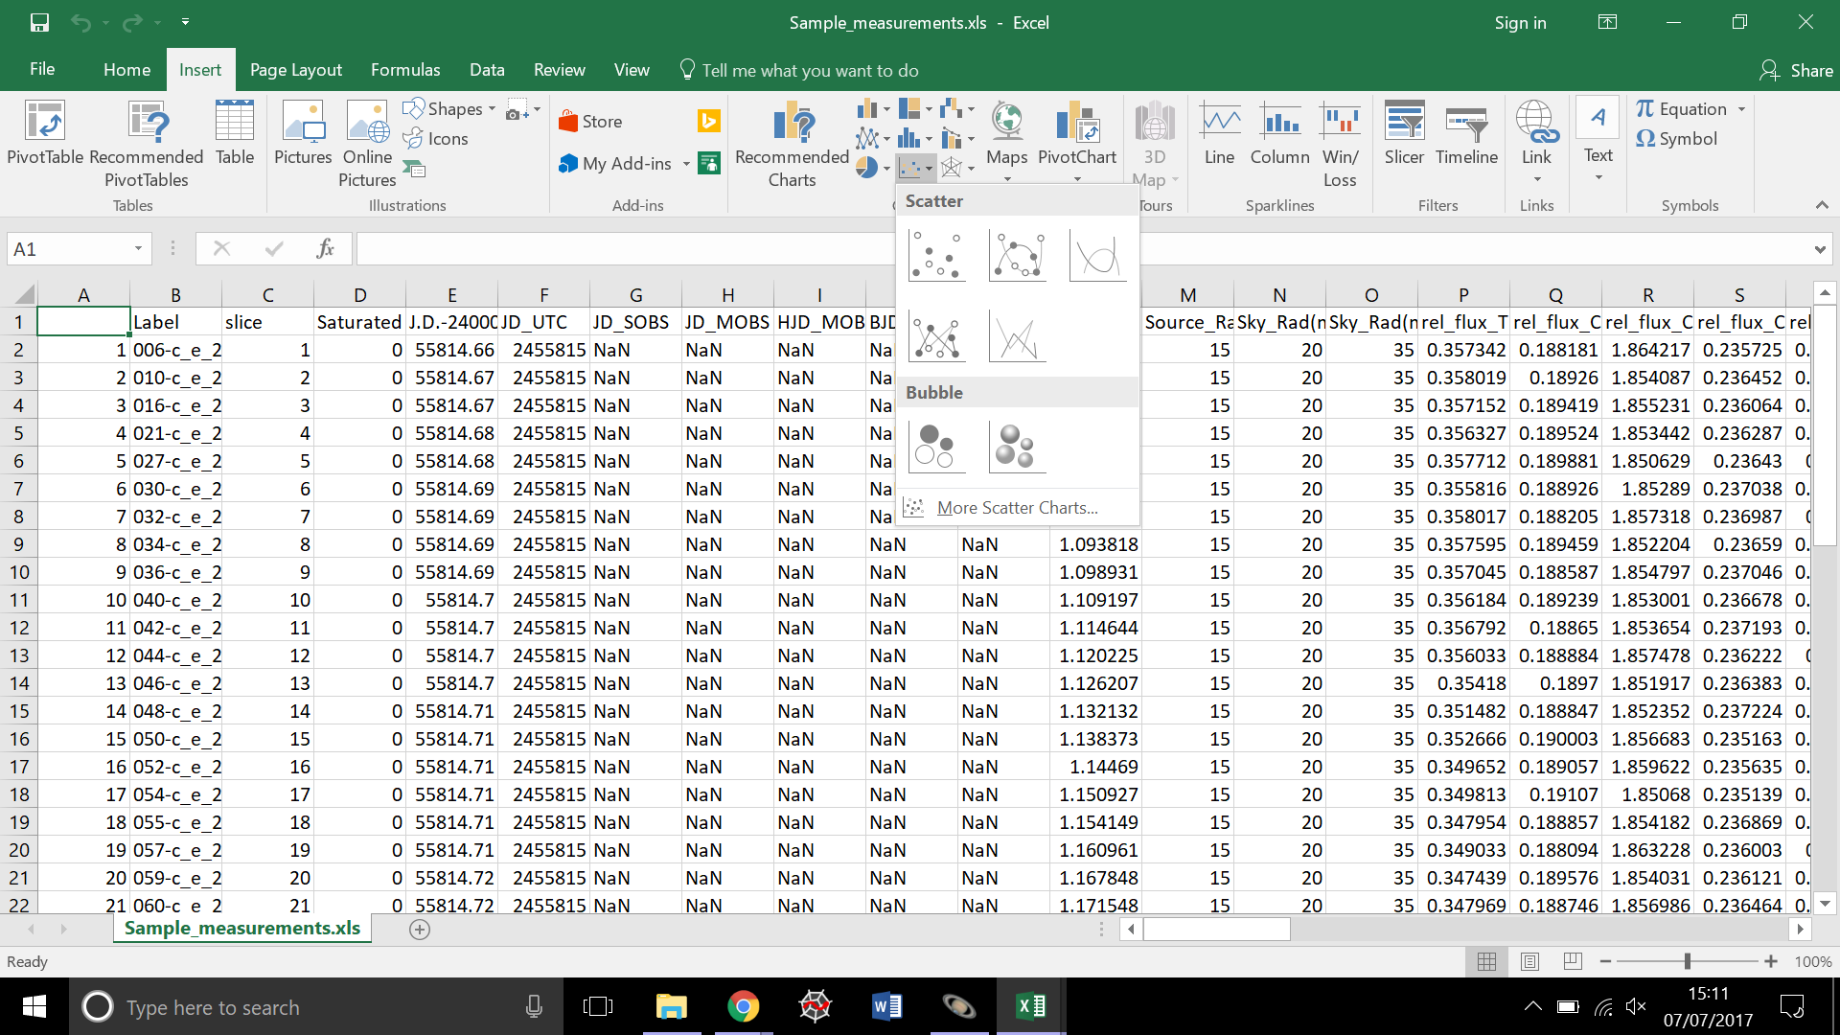

**Figure 3 - Plotting a scatter chart to produce a light curve in Excel.**

Step 9: You will need to **reverse the values of your y-axis**. This is because lower magnitude values represent brighter objects than higher magnitude values.

Note: See Calculating Magnitudes worksheet for further explanation.

Step 10: To do this, double click on your values on the y-axis of the graph. A toolbar on the right-hand side of the document should appear.

Step 11: Tick the box that says ‘**Values in reverse order**’. This is shown in Figure 4.

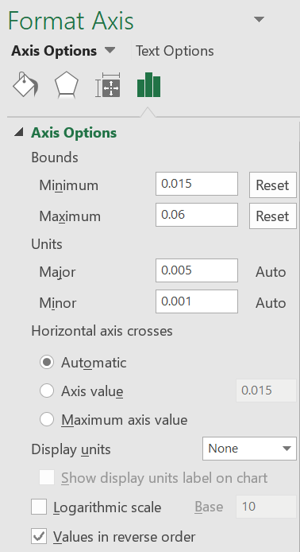

**Figure 4 – Reversing the y-axis in Excel.**

Step 12: After reversing the y-axis values, you will notice that the x-axis has moved to the top of your plot. To move it, double click on the y-axis to open the Format Axis toolbar as shown in Figure 4.

Step 13: Tick the **Maximum axis value** box under the ‘Horizontal axis crosses’ section.

Step 14: If there’s lots of white space in your graph, like in Figure 5, you may want to manually change the y-axis so that it doesn’t go to 0.

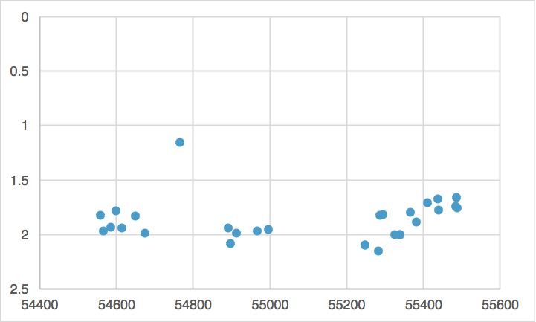

**Figure 5 - An example of a graph with too much vertical white space, produced in Excel.**

Step 15: To manually change your y-axis, type your desired upper limit of the y-axis in the ‘Minimum’ box under the ‘Bounds’ section as in Figure 4. For the example shown in Figure 5, we might choose an upper limit of 1.

Step 16: Experiment with the upper limit of your y-axis until you’re happy with how your light curve looks.

Step 17: To add labels to your axes, click on your graph and select **Design -> Add Chart Element -> Axis Titles** as shown in Figure 6.

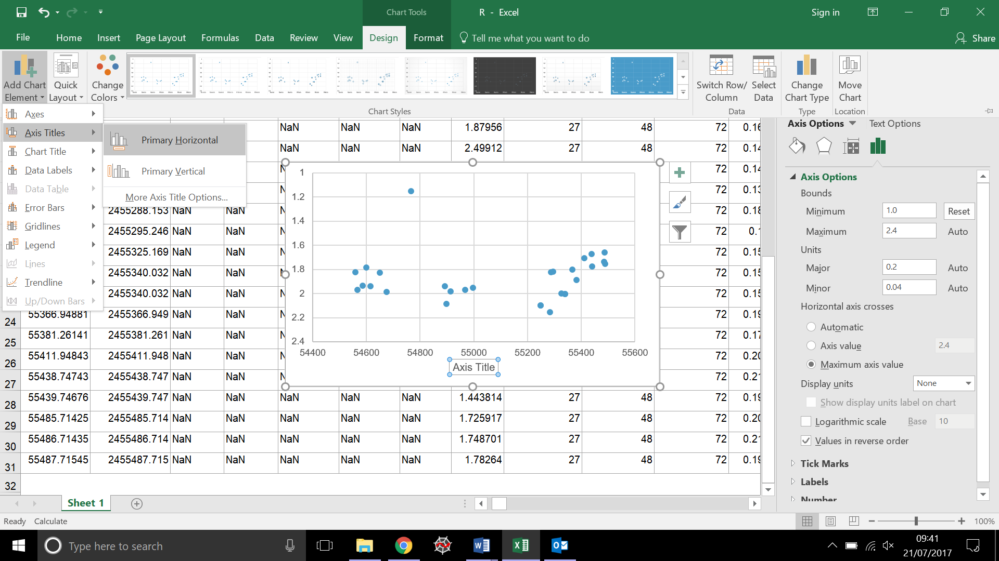

**Figure 6 - Adding labels to your axes in Excel.**

Step 18: Click on the y-axis label that’s been added and type ‘Magnitude’.

Step 19: Click on the x-axis label that’s been added and name it ‘J.D.-2400000’.

Step 20: To add a title to your plot, click on your graph and select **Design -> Add Chart Element -> Chart Title**

Step 21: Click on the title that’s been added and type “[object name] Light Curve”.

You now have a light curve of your target!

Note: For more information on magnitudes, see the ‘Calculating Magnitudes’ worksheet.

You can use your results in another activity to add error bars to your light curves.

To do this, refer to the ‘**Light Curve Error Bars with AstroImageJ & Excel**’ activity. This can be found on the Faulkes Telescope website.