**Light Curve Photometry with AstroImageJ**

Photometry

***How to perform photometry using the free image processing software, AstroImageJ***

AstroImageJ is an image processing software which is used to analyse FITS file images. These are the files that are produced by the Faulkes Telescope that you will be using in your investigation.

Step 1: First, open the AstroImageJ software programme.

Step 2: Go to **File -> Import -> Image Sequence**.

Step 3: In the pop up menu that appears, find where you’ve saved the image folder on your computer then select the first FITS file in the sequence or double click the folder where the FITS files are located.

Step 4: In the sequence options window that appears, tick “Use virtual stack”, leave ‘Sort names numerically’ ticked, then press OK.

If you do not already have it on your computer, you can download it from the link below:

<http://www.astro.louisville.edu/software/astroimagej/installation_packages/>

**Viewing your Images**

We want to make the images clearer so the objects stand out and are more easily resolved.

Step 5: Click on “**display as image negative**” toward the far left of the icon menu in the main AstroImageJ window. This is circled in green in Figure 1.

This is commonly used by astronomers as it inverts the image and shows individual objects more clearly, with a greater contrast to the background.

**Figure 1 - Selecting “display as image negative” in AstroImageJ.**

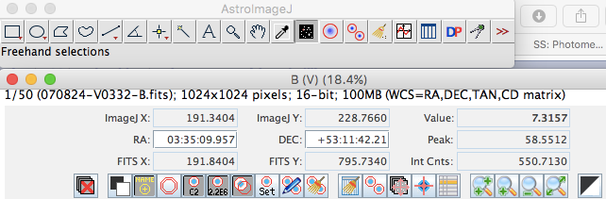

Step 6: Open your **Finder Chart**.

As telescopes use mirrors, the image is the reverse of how it actually appears. Therefore, if the image was not automatically flipped, your image may appear upside-down compared with your finder chart.

Photometry

Step 7: If you need to flip your image, go to **View -> Invert Y**.

Step 8: If you don’t think your image is clear enough you can adjust its brightness and contrast. If you need to do this, you can adjust the sliders shown in Figure 2.

**Figure 2 - Adjusting the brightness and contrast of images in AstroImageJ.**

**Selecting your Comparison stars**

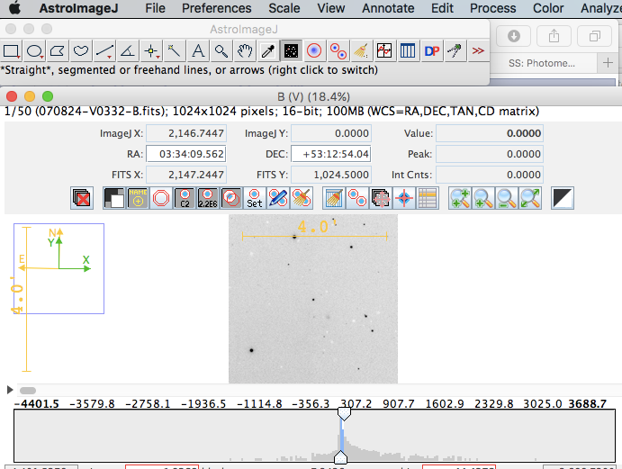

If you are performing photometry on multiple frames in order to see how the magnitudes of an object changes over time, any variability that is measured must be analysed. This is so that we can be sure we are measuring “**true variability**” and not variations caused by other factors.

Even for a star with constant magnitude, the number of photons that fall onto the pixels within a CCD will vary across images. As a result, the counts that are read also vary and the star would appear to change in magnitude.

There are a number of environmental factors that influence the counts of a star. To account for these variations, we use **comparison stars**.

Photometry

Note: See worksheet ‘Photometry in Astronomy’ for more information on environmental factors.

Comparison stars are stars that have been measured to establish that they are reliable, non-variable stars. Comparison stars appear in the same field of view as your target object and therefore will be affected in the same way by additional influences unrelated to the stars themselves (see “Photometry in Astronomy” worksheet for more information on environmental factors).

Once you have understood more about the variations that comparison stars display that can be attributed to environmental factors/seeing effects (See photometry worksheets), their magnitude can be subtracted from the magnitude of your target object. This allows you to obtain the **differential magnitude** of your target and determine its **true variability**.

Step 9: Select **3 or 4 stars** to be comparison stars in your image. They should be roughly the **same brightness** as your target object and should not be saturated or close to the edge of the image.

There is a limit to how many electrons each pixel can store, so for an exceptionally bright star or a long exposure, the pixel will reach its capacity and additional electrons will have to spread into the surrounding pixels. This is when the CCD becomes saturated and the resulting image will appear similar to Figure 3. When this happens, we are unable to get a reliable measure of how bright the star really is.

**Figure 3 - A saturated image of a star.**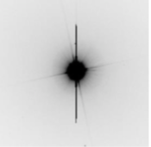

You will need to use the same comparison stars when measuring all your observations.

Step 10: You may want to check your chosen comparison stars are visible across all your images. This can be done by using the scroll bar under the image.

Note: We select 3 or 4 stars as we do not know if they are variable stars (varying magnitude) or non-variable stars (constant magnitude), this is in the hope that at least two of them will be non-variable stars.

Step 11: Of the target objects in each of the different images, select the image in which the target appears biggest to carry out the remaining steps of this worksheet. You only need to use one star in **one image** as all of your comparison stars should be of similar size and brightness.

Photometry

**Setting your Aperture Radius**

Before we can begin to take measurements of objects in the image, we must first find the most appropriate **aperture radius**.

This describes the **radius** of a circle that surrounds an area on an image in which the **pixel values are counted**.

Note: See Photometry in Astronomy for further explanation.

Step 12: Select the **line tool** in the main menu window, as shown in Figure 4.

**Figure 4 - Selecting the line tool in AstroImageJ.**



Step 13: Go back to the image window and draw a line over the target star (does not have to be horizontal but it needs to go through the centre of the star). Don’t draw the line too big such that a circle of this diameter would include more than your target. An example is given in Figure 5.

**Figure 5 - Example of using the line tool in AstroImageJ.**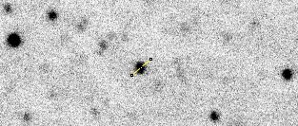

Step 14: Click **Analyze -> Plot seeing profile** and press “OK” on the pop up window.

Step 15: Remember or write down the 3 values in red toward the bottom of the window that appears, as in Figure 6.

**Figure 6 - Finding appropriate object radius, inner & outer radii of background annuli in AstroImageJ.**

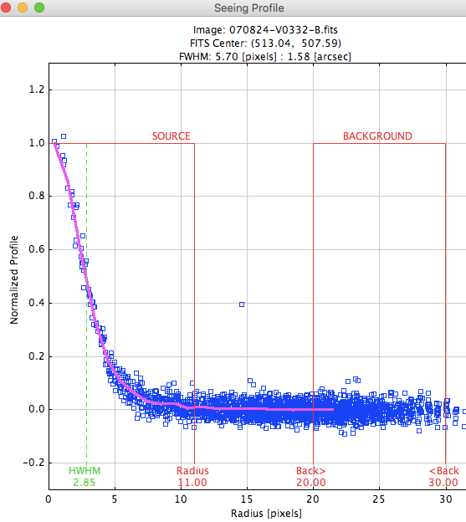



Photometry

**Photometric Analysis of your XRB target**

Step 16: Back in the main menu window, return to the first frame then select the **Multiple Aperture** tool as shown in Figure 7.

**Figure 7: Selecting the Multiple Aperture tool in AstroImageJ.**

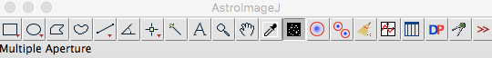

This will open another window in which you will set the object and sky apertures (Figure 8).

**Figure 8: Multi-Aperture Measurements window in AstroImageJ.**

Photometry

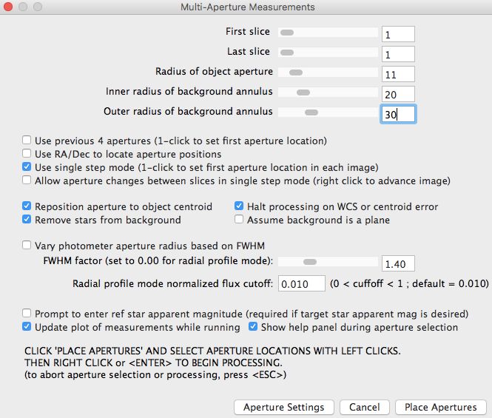

Step 17: Use the values you’ve remembered or written down in Step 10 to set the 3 values shown in Figure 8.

Step 18: Tick the “**single step mode**” box, then click “**Place Apertures**”.

Note: You cannot have a Radius of object aperture that is a larger value than the Inner radius of background annulus, nor can you have an Inner radius of background annulus that is a larger value than the Outer radius of background annulus.

The Inner & Outer radius of background annulus parameters measure the background light in the image within the radius that is set. These values are then subtracted from the object’s light in order to determine its brightness.

The most important parameter is the **Radius of object aperture** as this determines the radius within which the counts of the star is measured.



Photometry

Step 19: What part of your eye is comparable with the aperture radius used in photometry?

Step 20: Select the target first, then the comparison stars by clicking on them, without holding shift (Figure 9).

**Figure 9 - Selecting the target & comparison stars in AstroImageJ.**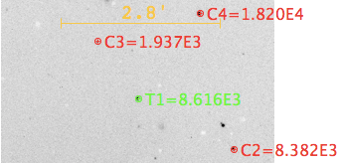

If you make a mistake, click on the incorrect aperture again to remove it.

Step 21: After selecting the stars, press the Enter key.

Step 22: Back in the image window click on the target in the next frame. Repeat until you get to the last frame.

Step 23: When you’ve clicked on the target in the last frame go to the Multi-Plot Main tab and select **File -> Save data to file**.

You are now ready to analyse your photometry measurements. Refer to the **Light curve plotting with AstroImageJ** worksheet to do this.