**Exoplanet transit calculations with AstroImageJ & Excel**

**How to perform calculations related to exoplanet transits using data from the free image processing software, AstroImageJ & Excel**

**Note: It is possible to complete some of the later calculations individually but you will need to complete some earlier steps regardless, so it is recommended that you read and complete the calculations in order.**

**Finding Transit time**

This will be done using the light curve you should have produced. Prior to carrying out this activity, you should have read through and completed the **‘Light Curve Photometry with AstroImageJ’**, **‘Light Curve Plotting with AstroImageJ’** and **‘Light Curve Error Bars in AstroImageJ & Excel’** worksheets.

Step 1: Open your Excel spreadsheet containing the data from your light curve.

Step 2: On your transit light curve, find the last data point before the exoplanet transit begins (This is when the dip in magnitude occurs).

Step 3: Hover over this data point, which will show you its coordinates. Find the value for the Julian date. Write down this value.

Step 4: Repeat steps 2 and 3 for the first point after the exoplanet transit ends. The 2 points described are circled in the light curve in Figure 1 below.

**Figure 1 – Finding the points at which the exoplanet transit begins and ends.**

Step 5: Subtract the date from the first point from that of the second to find the length of the transit in days.

**Finding Transit Depth**

This is done by taking a mean of the magnitudes at maximum (that is, when the exoplanet is not in transit) and then by taking the minimum magnitude during the transit. The difference between the two magnitudes is the transit depth.

Step 6: In your Excel spreadsheet of the data from your transit light curve, find the column entitled ‘J.D.-2400000’.

Step 7: In this column, find the numbers of the rows of the images which correspond to the Julian dates of the **beginning** and **end** of the exoplanet transit (how to find these is described in steps 2 and 3 of this worksheet).Write down these numbers.

The series of data points before and including the earlier number, and the series after and including the later number, should therefore collectively contain all the points when the exoplanet is not in transit (i.e. the “flat” areas of the lightcurve).

Step 8: If there are any points in your light curve that do not fit its trend contained in these series, follow steps 2-3 and 6-7 of this worksheet for these points to find the row numbers of the irregular points.

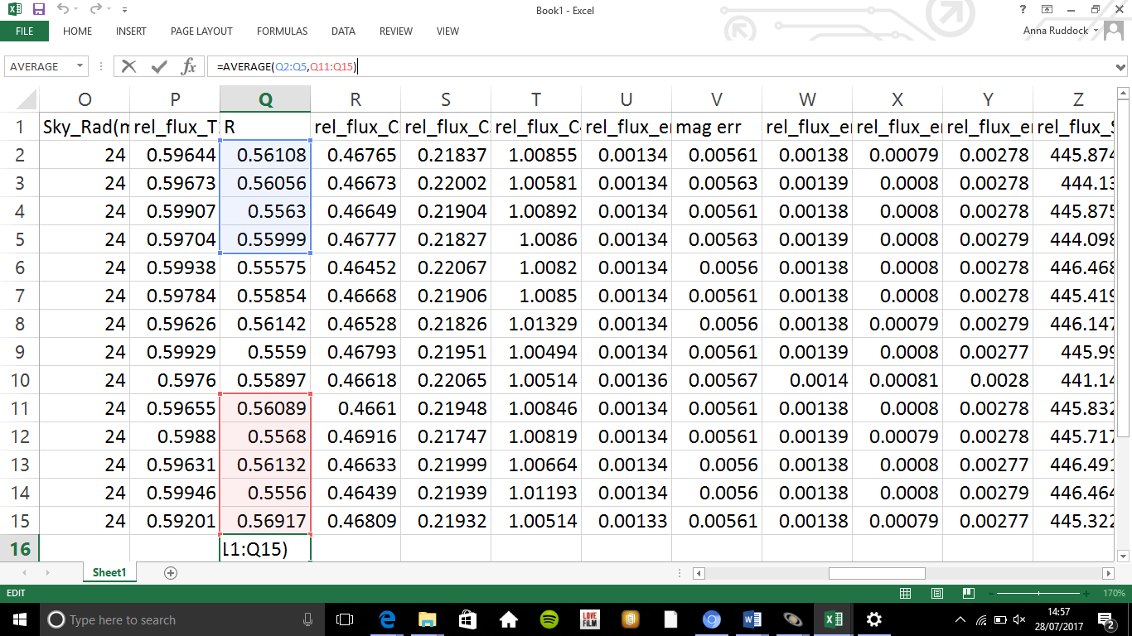 Step 9: In a cell that is not in use, type “ =AVERAGE( “ then while holding ctrl, highlight the data (in the magnitude column) in all the rows before and after the transit data, followed by typing “)”. After this, press Enter. This method is shown in Figure 2. Figure 3 also shows the points highlighted on a light curve.

**Figure 2 (left) – calculating the mean magnitude (out of transit) in Excel.**

**Note: If your data contains one or more anomalies and you have reasons for them being so, do not include them in the calculation of the mean. However, if you have no reason to discard the irregular points from the data set, you should make the calculation twice- once including the irregular points, once excluding them. You can then make a judgement on which result is as you expected and therefore more likely to be correct.**

**To exclude the data, follow step 9 as above, but more data sets will be highlighted as each one must be split to remove the points as needed. For example, a data set of 12-24 with an anomaly at 19 would be split into the 2 data sets 12-18 and 20-24.**

**Figure 3 – A light curve with the points to be included in the average highlighted (colours corresponding to the spreadsheet image).**

Step 10: From your light curve, find the lowest point (that fits your light curve’s trend) of the dip in magnitude caused by the exoplanet transit.

Step 11: Hover over this point to find the value for the magnitude at this point (the value on the Y-axis).

**Note: If your dip is flat-bottomed rather than pointed (an example of the difference is shown in Figure 4), instead of simply picking the lowest point in the graph, use the same function as in step 9 to take an average of the points at the bottom of the dip.**

**Figure 4- A flat-bottomed graph (left) for which a mean of the lowest magnitudes should be taken and a pointed-bottomed graph (right) for which the lowest point can be taken as the minimum.**

Step 12: Subtract the value for the lowest magnitude/the average of the lowest magnitudes from that for the average magnitude out of transit to find the transit depth.

**Calculating the percentage of the star’s light blocked by the exoplanet**

This ratio is calculated using the equation:

$\frac{∆F}{F}=\frac{R_{p}^{2}}{R_{*}^{2}}$, where $F$ represents the flux of T1 out of transit, $∆F$ represents the change in flux caused by the exoplanet transit, $R_{p}^{2}$ represents the radius of the planet squared and $R_{*}^{2}$ represents the radius of the star squared.

This equation uses data from the column in your Excel spreadsheet entitled **‘rel_flux_T1’**.

This measures the flux of T1.

Step 13: To find $F$, take a mean of the flux out of transit. To do this, follow steps 6-9 of this worksheet (however, if you have already calculated transit depth you may realise the numbers mentioned in steps 6-8 will be the same).

Step 14: To find $∆F$, you first need to find the minimum flux of T1. To do this, follow steps 10-11 for **‘rel_flux_T1’** instead of magnitude. .

Step 15: To find $∆F$ from the two values calculated, subtract the minimum flux value from the mean flux value out of transit of T1.

Step 16: To calculate the percentage of the star’s light blocked, substitute the values found for $F$ and $∆F$ into the left side of the equation above. This should give a decimal for $\frac{R_{p}^{2}}{R_{*}^{2}}$.

Step 17: Multiply this decimal by 100 to find the percentage.

**Calculating the ratio of the planetary to stellar radii**

For this calculation it is necessary to complete the ‘**Calculating the percentage of the star’s light blocked by the exoplanet’** section of this worksheet beforehand as the calculation continues from your answer gained in that section.

Step 18: Calculate the reciprocal of the decimal answer you obtained at the end of step 16. To do this calculate $\frac{1}{the decimal}$.For example, if the decimal was 0.2, calculate $\frac{1}{0.2}$ = 5.

Step 19: Calculate the square root of the answer obtained at the end of step 18.

Step 20: This answer gives the number of times longer the star’s radius is than the planet’s. Therefore in a planetary radius: stellar radius ratio in the form 1: n n represents this answer.