Exploring the Sky with Stellarium

Part A – investigating astronomical coordinate systems

Introduction

There are several systems that can be used to locate objects in the sky. We will distinguish here between two coordinate systems: azimuth/altitude (Az/Alt) and right ascension/declination (RA/Dec). Either one of these systems is analogous to using x- and y-coordinates on a piece of graph paper. They are two dimensional systems, which means that they can tell you where to look in the sky to find an object, but not how far away that object is from the Earth.

Alt/Az coordinates
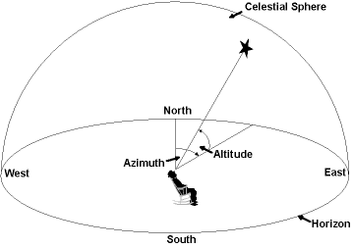
Azimuth - This is the direction of a celestial object, measured clockwise around the observer's horizon from north. So an object due north has an azimuth of 0°, one due east 90°, south 180° and west 270°.

Altitude - The angle of a celestial object measured upwards from the observer's horizon. Thus, an object on the horizon has an altitude of 0° and one directly overhead has an altitude of 90°. Negative values for the altitude mean that the object is below the horizon.

RA/Dec
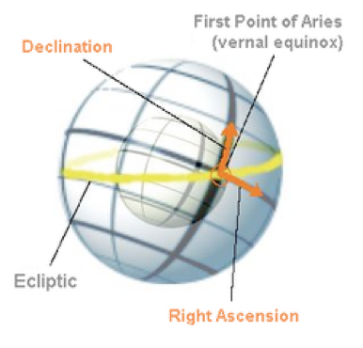
The projection of the terrestrial equator on the celestial sphere is called the celestial equator, while the projection of the poles are called the celestial north pole and celestial south pole. The point directly above an observer is called the zenith.

RA - Right ascension is the celestial equivalent of terrestrial longitude. Both right ascension and longitude measure an angle that increases toward the east as measured from a zero point on an equator. For longitude, the zero point is the Prime Meridian on the geographic equator; for right ascension, the zero point is known as the first point of Aries, which is the place in the sky where the Sun crosses the celestial equator at the March equinox.

Declination - Declination in astronomy is comparable to geographic latitude but projected onto the celestial sphere. Declination is measured in degrees north and south of the celestial equator. Points north of the celestial equator have positive declinations, while those to the south have negative declinations.

- An object on the celestial equator has a declination of 0°.
- An object at the celestial north pole has a declination of +90°.
- An object at the celestial south pole has a declination of −90°.

From the observer’s point of view, the most natural system is the alt/az one. Such a system however is time and position dependent: the coordinates of the same star at the same epoch are different for different observers. For these reasons, these coordinates cannot be used, for instance, in star catalogues. Unlike Alt/Az coordinates, RA/Dec coordinates of a star do not change if the observer changes latitude, and do not change over the course of the day due to the rotation of the Earth. RA/Dec coordinates are frequently used in star catalogues. We will investigate this in this assignment.

Procedure

- Launch Stellarium and set your location to Swansea and the time zone to UTC.

- Turn and face North. Toggle on the Azimuthal grid (z) from the horizontal menu bar, look up a bit, zoom out if it helps you, and examine the coordinate system.

Azimuth is the angle measured in a horizontal circle, around your horizon. Due N = 0°. Head around the circle, and E=90°, S=180°,W=270°and back to N = 360°.

Altitude is the angle measured from the horizon (0°) to the zenith (90°, or directly overhead). Thus, any point in the sky that you can see can be specified by telling you which direction to face (az), and how high up to look (alt).

- Fill out the blanks in Table 1 with your results from questions Q1 to Q6.

Location on Earth | Date & Time | Azimuth (Az) (°) | Altitude (Alt)(°) | RA (h:m:s) | Dec (° ‘ “)
Swansea | 20/10/22  22:00UT
Swansea | 20/12/22  22:00UT
Swansea | 20/2/23  22:00UT
Santa Barbara, California | 20/12/22  22:00UT
Santa Barbara, California | 20/2/23  22:00 UT

Table 1 – results from Stellarium investigation

Q1. Set your time for 20th October 2022, at 10:00PM (22:00 UT). Locate the star Vega and record its apparent az/alt coordinates to the nearest degree (click on the star, and notice the information that appears in the top left of your screen) in the table above. Pay attention to how these coordinates correspond to the star’s location in the sky.

Q2. Toggle between equatorial and azimuthal mount. Notice the difference! The azimuthal mount parallels the az/alt coordinates. The equatorial mount makes no sense if you imagine you are outside looking at the sky with your naked eye, but makes sense if you imagine that you are looking through the eyepiece of a telescope. Many telescopes are mounted parallel to the celestial equator, which makes adjusting to find objects easy using RA/dec coordinates.

Q2 a). Does changing the telescope mount change the location of the object in the sky?

Q3. Toggle off the az/alt coordinates (z), and toggle on the equatorial grid (e). You are now looking at the right ascension/declination coordinate system.

Record the J2000 coordinates for Vega in table 1 and notice that RA is not given in degrees.

Q4. Move forward 2 months but keep the time the same (so at 20/12/22 at 22:00 UT) and record the apparent az/alt coords and RA/Dec (J2000) positions for Vega in the table above.

Q5. Move forward another 2 months (to 20/2/23 at 22:00UT) and record the apparent az/alt coordinates and RA/dec (J2000) positions of Vega on this time and date in table 1.

Note that even if the star dips below your viewing horizon, its position is still displayed.

Q6. Now change your location to Santa Barbara, California and repeat the above (recording coordinates) for the same star on 20/12/22 and 20/02/23 at 22:00UT.

Q7. If you were an astronomer here in Swansea who needed to tell a colleague at Kitt Peak (in Arizona) about a sky object, which coordinate system would you use to communicate its location and why? Refer to your findings from the table above in your answer.

Part B – Investigating sunrise and sunset

We all know that the Sun rises in the east and sets in the west, right? In this part of the assignment we will examine the position and time of the rising and setting Sun over the course of the year and see how true that is.

Procedure:

- Launch Stellarium and set your location to Swansea and the time zone to UTC.

- Fill out the blanks in Table 2 with your results from questions Q1 to Q3.

Date | Time (UT) | Az (°) | Sunrise/Sunset?
20/3/22 |  |  | Sunrise
20/3/22 |  |  | Sunset
21/6/22 |  |  | Sunrise
21/6/22 |  |  | Sunset
23/9/22 |  |  | Sunrise
23/9/22 |  |  | Sunset
21/12/22 |  |  | Sunrise
21/12/22 |  |  | Sunset

Table 2 – results of Stellarium investigation of sunrise/sunset

Q1. Set your date for 20/03/22, and find the rising Sun. Guess at the time, then refine your time until the Sun has an altitude of +0°. Get as close as you can, and record the time and apparent azimuth coordinate in Table 2.

Q2. Advance the time to sunset, and record the time and azimuth coordinate in Table 2.

Q3. Find the sunrise and sunset again on 21/06/22, 23/09/22, and 21/12/22 and record the az values together with the times for both sunrise and sunset in Table 2 above.

Q4. Does the Sun rise due east every day? Explain your answer.

Q5. Does the Sun set due west? Explain your answer.

Q6. On which of the above dates from the table does the Sun rise farthest to the north? (think about how azimuth is measured).

Q7. What is the significance of the 4 days in the table?

